Exercise 1 Look , read and tick () or cross (×) :
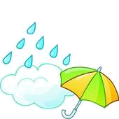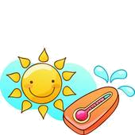
It's sunny.
It's snowing.
It's windy .
It's raining .

It's hot.
It's windy.

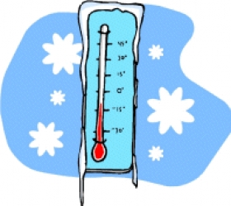
It's raining.
It's sunny.
It's raining.
It's cold.
It's windy .
It's raining.

Exercise 2 Choose the correct words :
1. Put on your sweater. It is very cold/hot today.
2. It is rainy/sunny today. Take the umbrella.
3. Let’s go to the beach. It’s very hot/rainy.
4. It is cloudy /sunny today. It may rain.
5. It’s snowy/ hot today. Let’s make a snowman.
6. The wind is cold/hot . Don’t catch a cold.
7. The weather is windy /cloudy today. Take your umbrella.
8. The weather is bad /nice/. Let’s go for a walk.

